Teacher Development Centre Chemistry
CHEMISTRY 12
Electrochemistry TEST

QUESTION/ANSWER BOOKLET

Part A – Multiple Choice Section:
Answer the following 15 questions by printing the appropriate letter on the answer sheet provided.

- Which of the following substances is added in the Hall-Heroult process to lower the melting point of electrolyte?

a) Bauxite
b) Alumina
c) Cryolite
d) Sodium hydroxide

2. In the “Carbon In Pulp” process used in the extraction of Gold the purpose of the carbon is to aid in which part of the overall process?

- froth floatation
- absorption
- electrochemical conduction
- electro-refining and purification

3. Inert electrodes that could be used in extracting of GOLD could include the following?

- Aluminium, Platinum, Carbon
- Gold, Carbon, Silver
- Platinum, Carbon
- Gold, Silver

4. Silver oxide cells are used for hearing aids and watches. The cell reaction is

Ag₂O_{(s)} + Zn_{(s)} + H₂O₍₁₎ → 2Ag_{(s)} + Zn(OH)_{2(s)}

At the cathode of this cell
- zinc metal is reduced
- zinc metal is oxidised
- silver ions are reduced
- silver ions are oxidized

5. When comparing galvanic (or electrochemical) cells with electrolysis cells it is true to say

- reduction occurs at the negative electrode in a galvanic cell
- reduction occurs at the cathode in both cases
- the anode is positive and the cathode is negative in each case
- the anode and cathode are interchangeable in a galvanic cell

6. A reading of one ampere is equivalent to a flow of 6.23 x 10¹⁸ electrons per second. This large number of electrons could form what mass of silver from a silver nitrate solution in one second?

a) 1.12 milligrams
b) 67 milligrams
c) 1.08 grams
d) 107.9 grams

In the diagram below refers to the next two questions, the concentrations of all
ions listed are at 1 mol L^{-1.}

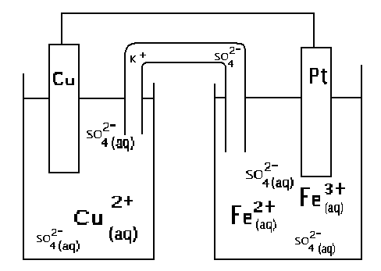

7. Referring to the above system

a) electrons will flow in the wire from Cu to Pt
b) electrons will flow in the wire from Pt to Cu
c) electrons will flow through the salt bridge from Cu²⁺_{(aq)} solution to the Fe²⁺_{(aq)} solution
d) electrons will flow through the salt bridge from Fe²⁺_{(aq)} solution to the Cu²⁺_{(aq)} solution

  - If a voltmeter was placed in the circuit above between the copper and
platinum electrodes what is the expected Voltage reading?

- 1.11
- 0.61
- 0.43
- 0.25

9. Electrolysis of a colourless aqueous solution using carbon electrodes produced a brown colour around one of the electrodes and a metal was deposited on the other. The substance present in the aqueous solution could be

- potassium bromide
- zinc chloride
- silver iodide
- potassium iodide
Questions 10 and 11 refer to the electrochemical cell which is set up as shown in the diagram below

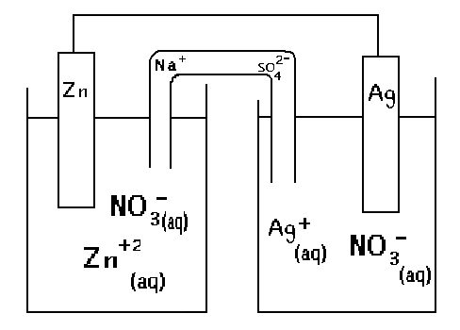

10. Which of the following statements is TRUE?

- Zinc deposits from the solution onto the zinc rod
- The silver rod dissolves in the solution
- Electrons flow through the external circuit from the solver rod to the zinc
- Nitrate ions migrate slowly through the salt bridge from the AgNO₃ solution to the Zn(NO₃)₂

11. What is the emf generated by the cell?

- 2.36 V
- 2.32 V
- 1.56 V
- 0.84 v

12. An object made of copper is plated silver by making it the cathode in an electrolysis process. The anode and the electrolyte would need to be

- copper and silver nitrate solution
- silver and silver nitrate solution
- silver and copper sulphate solution
- silver and dilute nitric acid

- What current would be needed to completely decompose 1.0 gram of molten
sodium chloride in 20 minutes?

a) 2.0 X 10⁶ Amp b) 21mA c) 20.5 A d) 1.4 A

14. Two cells are shown in the diagram below

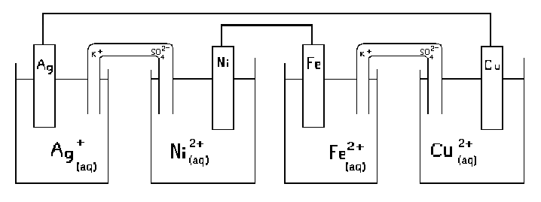

Which of the following statements best describes the processes occurring in the two cells. (use E⁰ values)

- Cell 1 behaves as an electrochemical cell, and electrolysis occurs in cell 2.
- Cell 2 behaves as an electrochemical cell, and electrolysis occurs in cell 1.
- Both cell 1 and cell 2 behave as electrochemical cells
- Electrolysis occurs in both cells 1 and 2

15. A steady current is passed for a fixed time through three cells containing
aqueous solutions and platinum electrodes as shown below
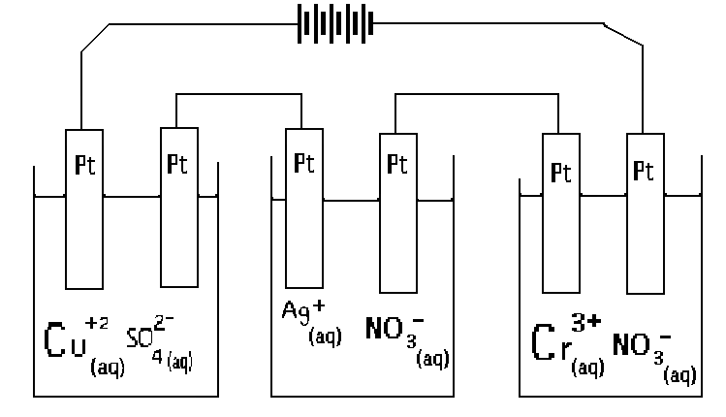

The molar ratio n(Cu) : n(Ag) : n(Cr) : of metal deposited at the negative electrode in each cell is

  - 2:1:0
  - 2:1:3
  - 2:3:1
  - 3:6:2

PART 2: SHORT ANSWER SECTION
Answer the questions below on the special answer sheet.
_____________________________________________________________________________

1. Write balanced ionic equations for any reactions that occur when the following substances are mixed.

a) Zinc is reacted with steam. (1 mark)
b) Copper metal is added to concentrated nitric acid. (1 mark)
c) Copper metal is added to dilute hydrochloric acid. (1 mark)

2. The corrosion of steel structures is a serious world-wide problem. The initial stages in the rusting process can be represented by the unbalanced equation.

Fe₍₅₎ + O_{2(g)} + H₂0₍₁₎ → Fe²⁺_{(aq)} + OH_{(aq)}

a) Write the half equation for the anode reaction. (1 mark)
b) Write the half equation for the cathode reaction. (1 mark)
c) Balance the equation above. (1 mark)
d) Calculate the cell potential for a standard cell based on
this reaction (1 mark)
e) With the aid of standard reduction potentials, briefly explain
how zinc metal functions as a protective coating on galvanized
iron (1 mark)

3. A 1 mol L⁻¹.KI solution is electrolysed using inert platinum electrodes.

a) Write equations for the
(i) cathode reaction
(ii) anode reaction
(2 marks)

b) Predict the minimum e.m.f. which needs to be supplied for
the reaction to take place. (3 marks)

4. An electric current is passed through a solution of silver nitrate. 20.0 grams of silver is deposited after a period of 30.0 minutes. Determine the current reading during the electrolysis period.
(4 marks)

5. How many litres of chlorine gas measured at STP are released by the passage of 8.12 amperes for 2.00 hours through molten magnesium chloride?
(3 marks)

ANSWER SHEET

Electrochemistry Test Year 12 NAME : __________________

Part A . Print the letter choice for the Part A Objective questions in the table below.

Question | Answer |  | Question | Answer
1 |  |  | 9
2 |  |  | 10
3 |  |  | 11
4 |  |  | 12
5 |  |  | 13
6 |  |  | 14
7 |  |  | 15
8
(2 marks each, 30 marks)
Part B.
  - a) ______________________________________________________________(1)

- _____________________________________________________________(1)

c) ______________________________________________________________(1)

2. a) ______________________________________________________________ (1)
b) ______________________________________________________________(1)
c) ______________________________________________________________(1)
d) ______________________________________________________________(1)
e) ______________________________________________________________
______________________________________________________________
______________________________________________________________(1)
3. a) Cathode Rn ___________________________________________________(1)
Anode Rn ____________________________________________________(1)
b) e.m.f. ______________(1)

4.  (4) | 5  (3)

Answer Key

Part A

Question | Answer |  | Question | Answer
1 | C |  | 9 | C
2 | B |  | 10 | D
3 | C |  | 11 | C
4 | C |  | 12 | B
5 | A |  | 13 | D
6 | A |  | 14 | A
7 | B |  | 15 | D
8 | D
(2 marks each, 30 marks)
Part B.
  - a) Zn_{(s)} + 2 H₂O_{(l)} → Zn²⁺_{(aq)} + H_{2(g)} + 2 OH⁻_{(aq)} (1)

- 3 Cu_{(s)} + 8 H⁺_{(aq)} + 2 NO⁻_{(aq)} → 3 Cu²⁺_{(aq)} + 2 NO_{2(g)} + 4 H₂O_{(l)} (1)

c) NO REACTION (1)

2. a) Anode Rn. Fe → Fe²⁺ + 2 e⁻ Eº = 0.44 V (1)
b) Cathode Rn. O₂ + 2 H₂O + 4 e⁻ → 4 OH⁻ Eº = 0.40 V (1)
c) 2 Fe_{(s)} + O_{2(g)} + 2 H₂O → 2 Fe²⁺_{(aq)} + 4 OH⁻_{(aq)} (1)
d) Eº nett is 0.84 V (1)
e) Zinc has an Eº 0.76 V this potential is higher than Iron’s at 0.44 V so the zinc will oxidize before the iron having that greater reactivity (1)
3. a) Cathode Rn 2 I⁻ → I₂ Eº = -.54V (1)
Anode Rn K⁺ + e⁻ → K Eº = -2.93 V (1)
b) e.m.f. -0.54 +(-2.93) = -3.47 V So more than 3.47 V required. (1)
4. AgNO₃ → Ag⁺ + NO⁻₃  Ag⁺ + e⁻ → Ag (1)  n(Ag) = 20/107.9 = 0.185 moles (1)  Q = 0.185 x 96500 = 17890 Coulomb (1)  I = Q/t = 17890/ (30 x 60) = 9.94 A (1)  (TOTAL 4) | 5. MgCl₂ ⇆ Mg²⁺ + 2 Cl⁻  Q = It = 8.12 x 2 x 3600 = 58464 C  n (e⁻) = Q/96500 = 58464/96500 = 0.606 mol. (1)  2 Cl⁻ → Cl₂ + 2 e⁻  n (Cl₂) = ½ n(e⁻) = ½ x 0.606 = 0.303 mol (1)  Vol (Cl₂) = n x 22.4 = 0.303 x 22.4 = 6.79 Litre at STP. (1) (TOTAL 3 )

